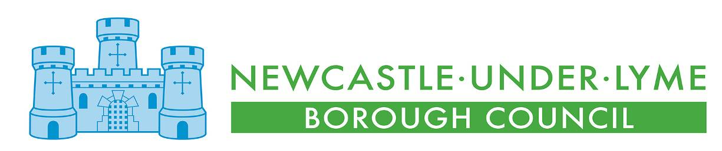
THE BOROUGH COUNCIL OF NEWCASTLE-UNDER-LYME

Council Member Code of Conduct Complaint Form

Introduction

This form is for complaining that a Newcastle-under-Lyme Borough Councillor, or a Councillor sitting on one of the Town or Parish Councils in the borough, has acted in breach of their relevant Council Code of Conduct. This form is not for any other type of complaint.

In order for a complaint to be considered, the Councillor in question must have been acting in their capacity as a Councillor at the time of the issue complained about. The Code of Conduct does not apply to Councillors when they are not acting in that capacity.

The conduct complained about must also have occurred within the last 12 months. We may consider older complaints, but you must set out in this form exceptional circumstances as to why the complaint wasn’t made within 12 months.

Use of Data

We will use the information you provide to assess, investigate and determine your complaint and in accordance with data protection legislation. This will include sharing that data with the Council Member you are making a complaint about, and if necessary other relevant individuals such as an investigator, witnesses, councillors on a panel that may be convened to determine the complaint and “independent persons” who are appointed by law to help the Monitoring Officer consider your complaint.

If you do not want us to share your information, you need to tell us why in this form. This may mean we are not able to consider your complaint, because being unable to share your information may restrict our ability to thoroughly consider your complaint, and the Council Member’s ability to fully respond to it. We will need to be satisfied that there is a good reason not to share information, and that the complaint can still be properly and fairly investigated.

We keep all records for a period of 3 years following determination of the complaint, so that we can address any challenges to the process that may arise during that time.

Section 1 – your details

Please provide us with your name and contact details:

Title
First name
Last name
Address

Daytime telephone
Evening telephone
Mobile telephone
Email

Section 2

Please tell us which best describes you:
✓
Member of the public
An elected or co-opted Councillor of an Authority
Member of Parliament
Other Council officer or Authority employee
Other (please specify)

Section 3

Please provide the name of the Councillor(s) you believe have breached the Code of Conduct and the name of their council or authority.

FIRST NAME | LAST NAME | COUNCIL OR AUTHORITY NAME

Section 4

Please explain in this section (or on separate sheets if preferred) what the Councillor has done that you believe breaches the Code of Conduct.

For each Councillor complained about, please set out which Code of Conduct you think applies, and which parts of it the Councillor(s) in question have breached.

If you are complaining about more than one Councillor you should clearly explain what each individual person has done that you believe breaches the Code of Conduct.

It is important that you provide all the information you wish to have taken into account. For example:

- You should be specific, wherever possible, about exactly what you are alleging the Councillor said or did. For instance, instead of writing that the Councillor insulted you, you should state what they said or did.
- You should provide the dates of the alleged incidents wherever possible. If you cannot provide exact dates it is important to give a general timeframe.
- You should confirm whether there are any witnesses to the alleged conduct and provide their names and contact details if possible. We may contact witnesses you tell us about.
- You should provide any relevant background information

ONLY COMPLETE THE NEXT SECTION IF YOU DO NOT WANT US TO SHARE INFORMATION ABOUT YOUR COMPLAINT

Please provide us with details of why you believe we should withhold your name and/or the details of your complaint

Section 5 - Additional Help

Complaints must be submitted in writing. This includes electronic submissions. However, in line with the requirements of the Disability Discrimination Act 2000, we can make reasonable adjustments to assist you if you have a disability that prevents you from making your complaint in writing.

We can also help if English is not your first language.

If you need any support in completing this form, please let us know as soon as possible.

Signed:

Dated:

Please return your completed form to:

The Monitoring Officer,
Newcastle Borough Council,
Castle House,
Barracks Road,
Newcastle,
Staffs, ST5 1BL

Email: MemberCodeofConduct@newcastle-staffs.gov.uk

Revised February 2024

