Last Updated DAY MONTH YEAR
Please edit all areas in red to customise this plan for your education setting
INSERT BUSINESS NAME
NAME HERE
Sustainability Action Plan

Introduction

INSERT SHORT INTRODUCTION TO THE BUSINESS AND ITS VISION/STRATEGY FOR SUSTAINABILITY AND CLIMATE ACTION.
This action plan has been created in collaboration with Climate Ambassadors which is funded by the DfE with the main aim to have all education settings have climate action plans by 2025. These action plans aim to support education settings to decarbonise, become adaptable and resilient to climate change, promote biodiversity, and deliver climate education and green skills.
INSERT PHOTO OF BUSINESS HERE

4 Pillars of Action Planning
Businesses can work towards their ambitions and create a more sustainable setting for staff and customers through the 4 pillars of action which are decarbonisation, adaptation and resilience, biodiversity, and climate education and green skills.
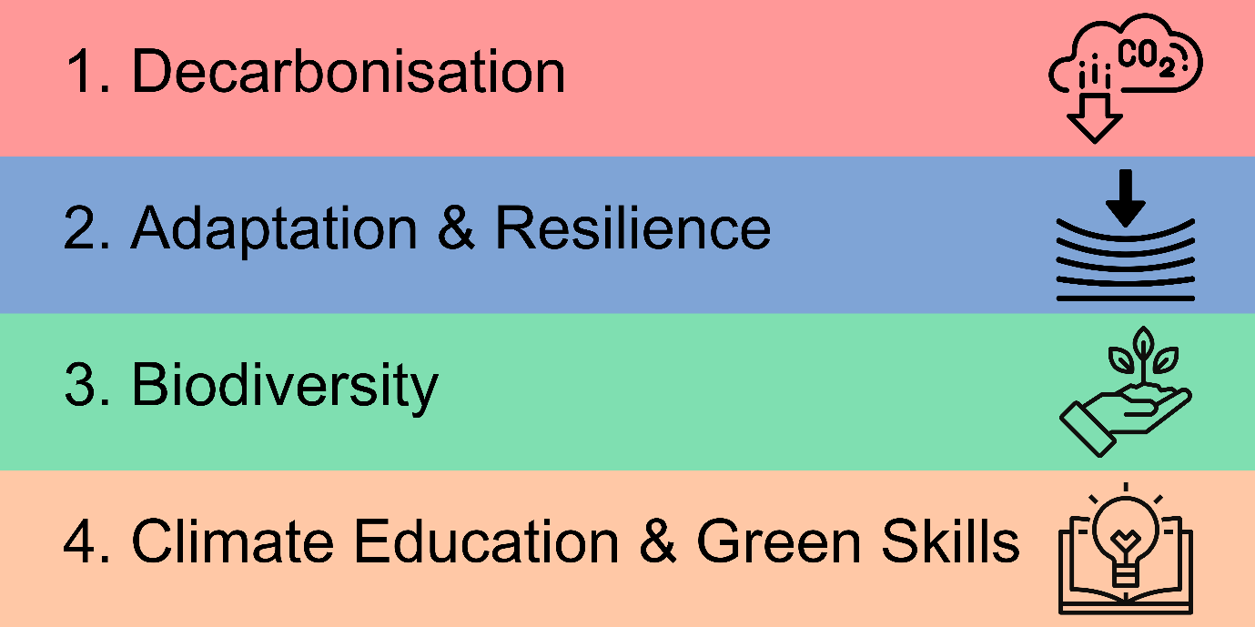
The first pillar of action for education settings to focus on is decarbonisation which encompasses the built environment, transport, and energy that businesses manage. Decarbonisation is defined as the “process of stopping or reducing carbon gases, especially carbon dioxide, being released into the atmosphere as the result of a process, for example the burning of fossil fuels (Cambridge, 2024).” businesses can work together to decarbonise current and new built developments through the introduction of more efficient interventions such as LED lighting, air source heat pumps and insulation. Transport wise businesses will need to focus on any vehicles the intuition might own and transition them to electric or to other renewable fuels, however the business will also need to focus on charging infrastructure and on the transportation methods that staff, and customers use to get and leave from the business. Lastly the energy the setting uses must be from renewable sources which can be bought through energy companies or be produced through on site solar for example. Through decarbonisation businesses can reduce their greenhouse gas emissions to net zero and reduce their impact their business has on Climate Change.

The second pillar of action for businesses is to focus on is adaptation & resilience which also encompasses everything, especially the land and built environment that education settings manage. Climate adaptation and resilience is defined as the “wide range of measures to reduce vulnerability to climate change impacts (UNDP Climate Promise, 2024).” Staff and customers alongside experts and other organisations can work together to create a more adaptable and resilient business setting to climate change through interventions such as more arable lands and walls to reduce flooding risk as this is high in England or for example create more green space and plant more trees to reduce the risk of heat islands developing which can cause heat stroke in staff and customers, especially with rising global temperatures. Businesses can create healthier environments that will both protect that area and those who use it from the adverse impacts of climate change and protect the areas which educate the next generation. Through adaptation & resilience businesses can reduce the risk of impact from climate change on their education setting, their staff, and their customers as the crisis continues.

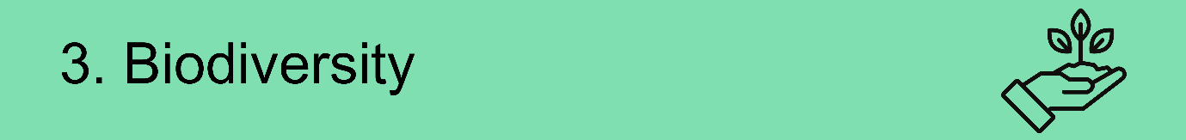

The third pillar of action for businesses to focus on is biodiversity which encompasses the natural environment and resources in education settings. Biodiversity is defined as “Biodiversity is all the different kinds of life you’ll find in one area—the variety of animals, plants, fungi, and even microorganisms like bacteria that make up our natural world. Each of these species and organisms work together in ecosystems, like an intricate web, to maintain balance and support life. Biodiversity supports everything in nature that we need to survive: food, clean water, medicine, and shelter (WWF, 2024).” Staff and customers alongside experts and other organisations can work together to nurture the natural side of the planet more in their own education settings and to protect the natural system that provides society with everything it needs to be stable from food, water, shelter and much more. Through biodiversity, businesses can support the recovery of the natural environment such as forests, grasslands, invertebrates, and small fauna within their localities and create more resilient environments.

The fourth and final pillar of action for businesses to focus on is climate education & green skills which encompasses the staff and customers, the business hosts. Climate education & green skills can be defined as “the knowledge, abilities, values and attitudes needed to live in, develop and support a society which reduces the impact of human activity on the environment (UK Parliament, 2024).” Staff and customers alongside experts and other organisations can work together to ensure sustainability is embedded in everything that the business do within their settings to ensure they have the skills and knowledge in society where all job sectors and areas of personal life will need to be done in a sustainable way. Through climate education & green skills, education settings create informed and active generations of society that will be able to continue exploring new solutions to climate change.

Action Code – Action codes allow education settings to easily identify different actions in different sections of their delivery plans. Each action code is made up of the first letter of the category that action is in and then numbered based on where they are in the list of actions.
Action/Goal – This section relates to the main title and description of an action that the education setting wants to take. As an example, in decarbonisation the action could be “to decarbonise the entirety of said education setting by 2030.” Choose from the drop-down list or create your own.
Items – This is where the education setting can write additional information and summary relative to the main action. This could be how it will be done, what it involves and small tasks needed to achieve the main action.
Lead(s) – This is where the education setting can assign the responsibility of an action to someone. Leads can be staff, students, a group like a green team or club or even external stakeholders. This ensures each action is accountable and has someone or multiple people responsible for achieving it.
Resources – This is where, if available, educations settings can detail the total and breakdown cost of the action.
Timeline – This is where the education setting can set the achievement date of the particular action to ensure the setting has a timescale. Make sure these are realistic to the capacity of your institution.
Carbon Saved (tCO2e) – This is where the education setting, if available, can detail how much carbon that action has saved through achieving it. This will mostly relate to actions in the decarbonisation action pillar.
Reporting/Progress – This section allows the education setting to keep track of different actions where your institution can add in progress updates. An example key for the progress tracker and predicted cost is below.

All actions will also need to have an associated difficulty, resource implication and progress update with dates which are detailed in the table below.

INSERT BUSINESS NAME HERE Sustainability Action Plan

This Action Plan has detailed below the actions INSERT BUSINESS NAME HERE needs to achieve by certain deadlines to dicarbon become more resilient to climate change, promote biodiversity, and develop climate education and green skills for staff and customers.
Where INSERT BUSINESS NAME HERE may not know the answer to an action yet then they can put “to be identified through consultation.”

All actions will also need to have an associated difficulty, resource implication and progress update with dates which are detailed in the table below.
Action Difficulty Tracker | Cost Tracker | Progress Tracker
Very Easy to Achieve  Easy to Achieve  Difficult to Achieve  Very Difficult to Achieve | £ = £0 - £1,000  ££ = £1,000 - £10,000  £££ = £10,000 - £100,000  ££££ = £100,000 - £1,000,000  £££££ = £1,000,000 - £10,000,000  ££££££ = £10,000,000 - £100,000,000 | Action Achieved & Ongoing  Action Achieved  Progress Underway  No Progress

INSERT BUSINESS NAME HERE
Climate Action Plan

For INSERT BUSINESS NAME HERE to decarbonise all the business’s-built environment, travel and transport, and other sources of greenhouse gas emissions such as procurement.

Action Code | Action | Items | Lead(s) | Resources | Timeline | Carbon Saved (tCO2e) | Reporting
D1
D2
D3
D4
For INSERT BUSINESS NAME HERE to adapt the business from the impacts of climate change and create a more resilient setting to these impacts.

Action Code | Action | Items | Lead(s) | Resources | Timeline | Carbon Saved (tCO2e) | Reporting
A1
A2
A3
A4
For INSERT BUSINESS NAME HERE to create a biodiverse and flourishing natural environment within the business setting focusing on local nature recovery.

Action Code | Action | Items | Lead(s) | Resources | Timeline | Carbon Saved (tCO2e) | Reporting
B1
B2
B3
B4
For INSERT BUSINESS NAME HERE to embed sustainability and climate education in the business to ensure all staff and customers have the knowledge and skills to continue embedding sustainability in everything they do now and in the future.

Action Code | Action | Items | Lead(s) | Resources | Timeline | Carbon Saved (tCO2e) | Reporting
C1
C2
C3
C4

This allows for INSERT BUSINESS NAME HERE to set out their own ambitions with students and staff in a realistic and impactful way to ensure they achieve the main goals of the 4 pillars.

Action Plan Governance

INSERT DESCRITION OF HOW YOUR BUSINESS WILL GOVERNE THIS DOCUMENT, PLEASE VIEW THE FRAMEOWKR GOVERNANCE ADVICE TO HELP DEVELOP THIS SECTION.

Conclusion

INSERT A SHORT CONCLUSON FOR YOUR BUSINESS WITH YOUR MAIN VISION/STRTAGY AND HOPE FOR THE WHAT THIS PLAN CAN DELIVER FOR YOUR STAFF, STUDENTS AND ENVIRONMENT.

INSERT CONCLUDING PHOTO

