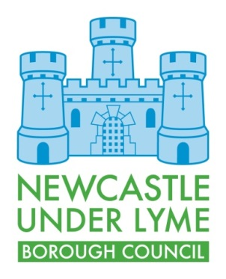
APPLICATION FOR STREET NAMING AND NUMBERING OF NEW PROPERTIES

- Applicant details
Name:

Address:

Post Code
Telephone:

Email:

What is your status in relation to the property? i.e owner, developer, agent, etc

- Address Information

Type of Development? | New build - residential
 | New build - commercial
 | Conversion - residential
 | Conversion - commercial
Do you require a new street name or house number, or both
If house number, how many plots?
If name, what are you proposing?
Expected construction start / finish date
Planning Application No;
Location of the development and any existing street names
You will be required to submit the 1) Location Plan 2) Site layout Plan and 3) Schedule of properties with this application

- Additional comments

Signed:

Dated:

If you require any help or assistance with this application, please contact 01782 742312

Please see our website for the relevant charging information

Please return completed applications together with any required documentation and payment to;

Regeneration & Development
Newcastle under Lyme Borough Council
Castle House
Barracks Road
Newcastle-under-Lyme
Staffordshire.
ST5 1BL

