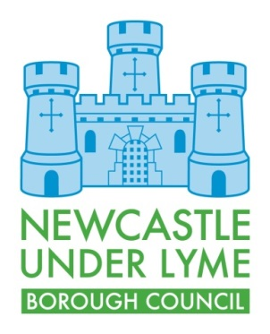
APPLICATION FOR STREET NUMBERING OF
EXISTING AND CONVERTED PROPERTIES

- Applicant details
Name:

Address:

Post Code
Telephone:

Email:

What is your status in relation to the property? i.e owner, developer, agent, etc

- Property

Existing property name or number
Do you require a new number or name?
Reason for the change?
If new name, what are you proposing?
Planning Application/Building Control No;
You will be required to submit the Local Plan with your application. The Plan should clearly show the outline of the property and also indicate the main point of access

- Additional comments

Signed:

Dated:

If you require any help or assistance with this application, please contact 01782 742312

Please see our website for the relevant charging information

Please return completed applications together with any required documentation and payment to;

Regeneration & Development
Newcastle under Lyme Borough Council
Castle House
Barracks Road
Newcastle-under-Lyme
Staffordshire.
ST5 1BL

